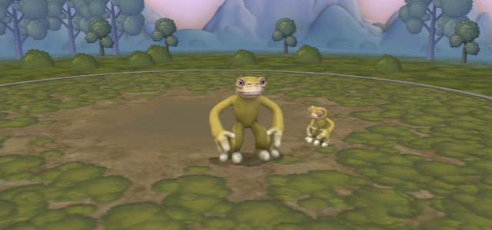**Survival Of The Fittest**

**The Origin of the Organism**

**Name:** *Mon dig*

Explain the details below!

**Habitat:** forest, sea, desert; explain where they exactly live and how the environment supports their life.

**Type:** animal (mammal, fish, bird, reptiles, amphibian, insect) plants**.**

**Morphological/Physical Condition:** The outer part of their body system characteristics.

**Physiological Condition:** Their inside body system characteristics.

**Behavioral Condition:** eat, move, reproduce, the way they live, etc

**Others:** special characteristics

1st environmental pressure: As the food supply is getting less and they can only be found at the top of the tree. The organism has to climb higher tree and *Mon dig* have short leg and arms to grab tree.

|  |  |  |
| --- | --- | --- |
|  |  |  |
|  |  |  |