Calculate the surface areas for each of the objects below.
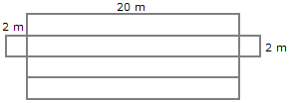
area = 168 cm²
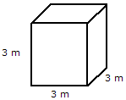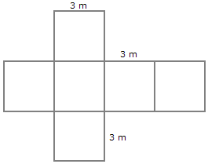
area = 54 m²
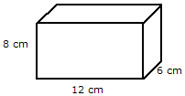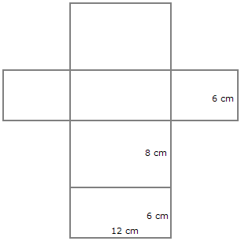
area = 432 cm²

Rectangular Prisms
Fill in the missing values for a rectangular prism.
1. length 2 width ________ height 12 surface area ________ volume 192 | 2. length 10 width 5 height ________ surface area ________ volume 650 | 3. length 8.1 width ________ height 14.43 surface area ________ volume 327.2724
4. length ________ width 7.82 height 5 surface area ________ volume 238.51 | 5. length ________ width 7 height 5 surface area 358 volume ________ | 6.
7. length 14.6 width 1.7 height 8 surface area ________ volume ________ | 8. length ________ width 1 height 14 surface area 418 volume ________ | 9. length 2 width ________ height 10 surface area 190.24 volume ________
10. length ________ width 3 height 7 surface area 102 volume ________ | 11. length ________ width 6 height 12 surface area 216 volume ________ | 12. length ________ width 13 height 7 surface area 302 volume ________
13. * This is a pre-made sheet. Use the link at the top of the page for a printable page. | 14. length 4 width 10 height ________ surface area ________ volume 40 | 15. length 6 width 2.19 height 9 surface area ________ volume ________

Surface Area
Find the surface area of each solid to the nearest tenth. (use = 3.14)
1. a = 21 cm b = 42 cm c = 40 cm d = 29 cm | 2. a = 5 mm b = 12 mm c = 9.1 mm d = 13 mm | 3. a = 4.8 in b = 6 in
4. * This is a pre-made sheet. Use the link at the top of the page for a printable page. | 5. a = 27 cm b = 32 cm c = 27 cm | 6. a = 4 in b = 16 in c = 6 in d = 5 in
7. a = 14 in b = 10.2 in | 8. a = 35 cm b = 15 cm c = 21 cm | 9. a = 33 mm b = 56 mm c = 9.5 mm d = 65 mm
10. a = 3.4 mm b = 5.8 mm c = 5.8 mm | 11. a = 23 in b = 2 in c = 6 in | 12. a = 35 cm b = 43 cm c = 24 cm d = 37 cm

Surface Area
Find the surface area of each solid to the nearest tenth. (use = 3.14)
1. a = 10 mm b = 14 mm c = 14 mm | 2. a = 5.1 in b = 17 in c = 17 in | 3. a = 3.9 cm b = 15.8 cm
4. | 5. a = 4 in b = 9 in | 6. a = 2 mm b = 11.7 mm
7. a = 10 mm | 8. a = 6 cm | 9. a = 3 in b = 17 in

