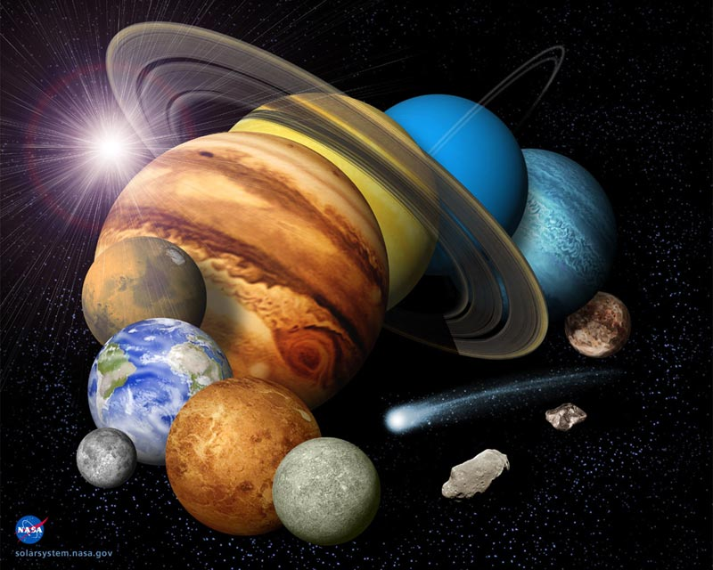
PYP6 1st Formative Assessment (Compare and Contrast between Earth and Other Planet(s).
How the World Works (Solar System)
Name: _________________________
Date: October 2012
Assessment Task : Students describe planetary facts
Assessment Tool : Checklist
Assessment Strategies : Observation

WALT (What Am I Learn To)
To know what the solar system consist of
Criteria | Independent | Evident | Developing | More time and effort
Identify celestial objects in our solar system
Describe characteristics of each celestial object
Explain the differences and similarities between Earth and other planet(s) (planetary comparative)
Conclude why Earth is the best planet to sustain human life
Use recording and organizing information skills
Cite references correctly
Create a readable, attractive and neat visual presentation based on MI

